


SAVEETHA INSTITUTE OF MEDICAL AND TECHNICAL SCIENCES (SIMATS)
Saveetha School of Engineering
Department of Computer Science and Engineering

SOFTWARE ENGINEERING
Technnical Report
TITLE : Design and Development of an Online Auction System with Real-Time Bidding

Submitted By
Name : Akileshwaran A
Register Number : 192511354
GUIDED BY

Course Faculty : Dr. K. ANITADAVAMANI

SIMATS ENGINEERING
Saveetha Institute of Medical and Technical Sciences Chennai - 602105
july- 2026

Table of Contents
Section | Page
1. Problem Analysis | 3
2. Project Structure Design | 4
3. Git Repository Initialization | 5
4. Git Branching Strategy | 6
5. Version Control Workflow | 7
6. Commit History Analysis | 8
7. Docker Environment Design | 9
8. Dockerfile Development | 9
9. Docker Compose Design | 10
10. Container Deployment and Testing | 10
11. Benefits of Git and Docker | 11
12. Challenges and Future Improvements | 12
Conclusion | 12

1. Problem Analysis
The project selected for this technical assignment is an Online Auction System with Real-Time Bidding. The system is designed to provide a web-based environment where users can view auction items and place bids. The implementation used in this assignment provides a simple auction interface for demonstrating application deployment using Git and Docker.

Project Objectives
• To organize the project source files using a Git repository.
• To demonstrate branching, commits, merging, and synchronization with GitHub.
• To containerize the web application using Docker.
• To use Docker Compose for application deployment.
• To test the application through a browser after container deployment.

Functional Requirements
• Display an online auction item.
• Display the current bid amount.
• Provide a Place Bid action.
• Show a successful bid message after the button is selected.
• Make the application accessible through a browser using a local Docker port.

Expected Outcomes
The expected outcome is a version-controlled and containerized auction web application that can be built, started, tested, and maintained using Git and Docker.

2. Project Structure Design
The repository is organized to keep source files, documentation, and container configuration easy to identify and maintain.
online-auction-system/
├── .git/
├── README.md
├── bidding.txt
├── index.html
├── Dockerfile
└── docker-compose.yml

Purpose of Major Files
• .git – stores Git repository metadata and version-control history.
• README.md – provides a basic project description.
• bidding.txt – represents the real-time bidding module information.
• index.html – contains the web interface for the auction demonstration.
• Dockerfile – defines how the application image is built.
• docker-compose.yml – defines the Docker service, port mapping, and volume.

Architecture Diagram
The following diagram should show the user accessing the web application through a browser, with the application running inside a Docker container using Nginx.
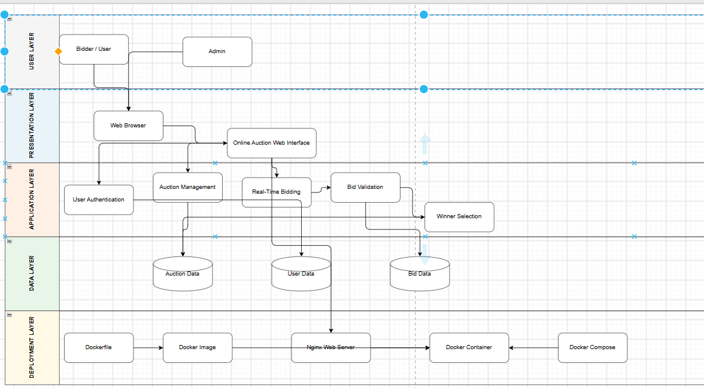

3. Git Repository Initialization
Git was initialized inside the Online Auction System project folder using git init. Files were then staged and the initial project version was saved using a meaningful commit message.
Commands used:
git init
git add .
git commit -m "Initial project setup"
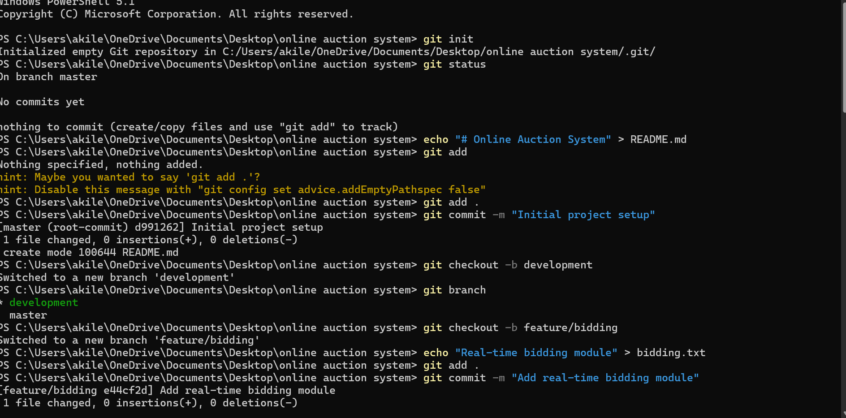

4. Git Branching Strategy
The project uses master, development, and feature/bidding branches. The master branch represents the stable project version. The development branch is used for integrating development work. The feature/bidding branch isolates the real-time bidding feature before integration.
Branching strategy:
feature/bidding → development → master

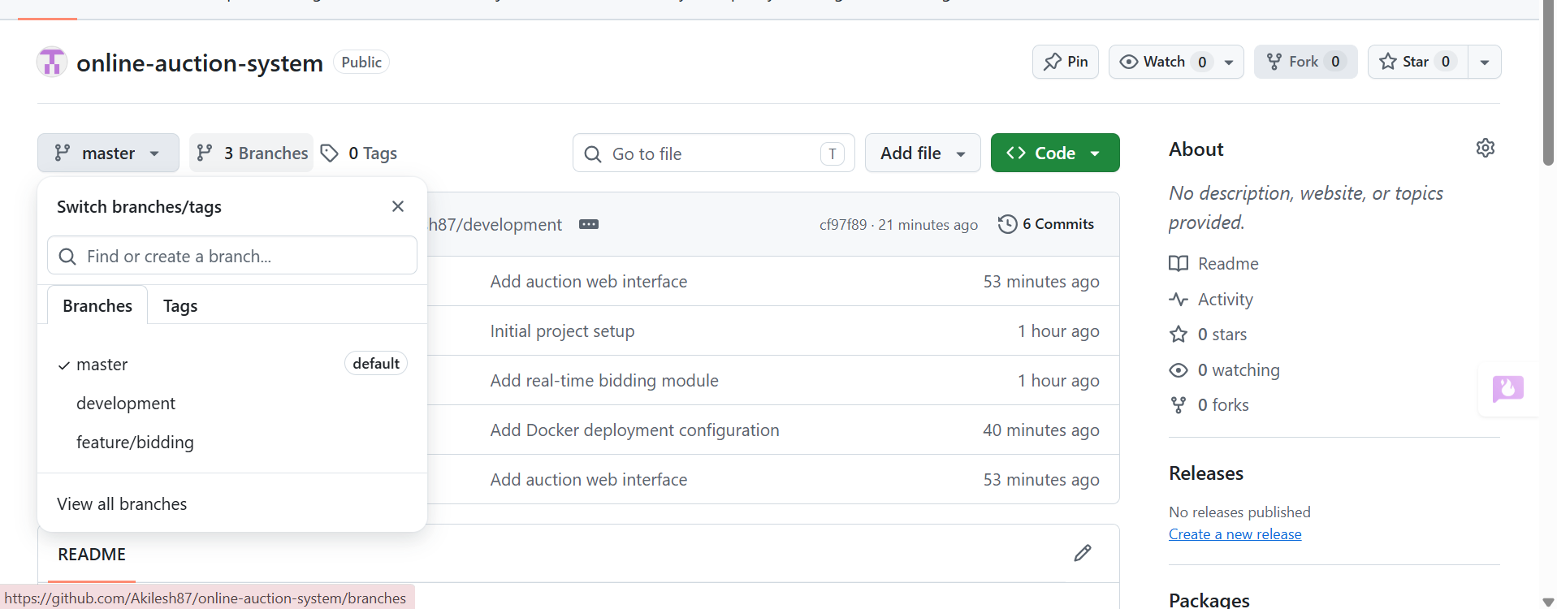

5. Version Control Workflow
The Git workflow was demonstrated through feature development, meaningful commits, branch switching, merging, and GitHub synchronization. The feature/bidding branch was created for the bidding feature and was merged into development. The development branch was then merged into master through a GitHub pull request.
Important operations included:
• git checkout -b feature/bidding
• git add .
• git commit -m "Add real-time bidding module"
• git checkout development
• git merge feature/bidding
• git push -u origin development
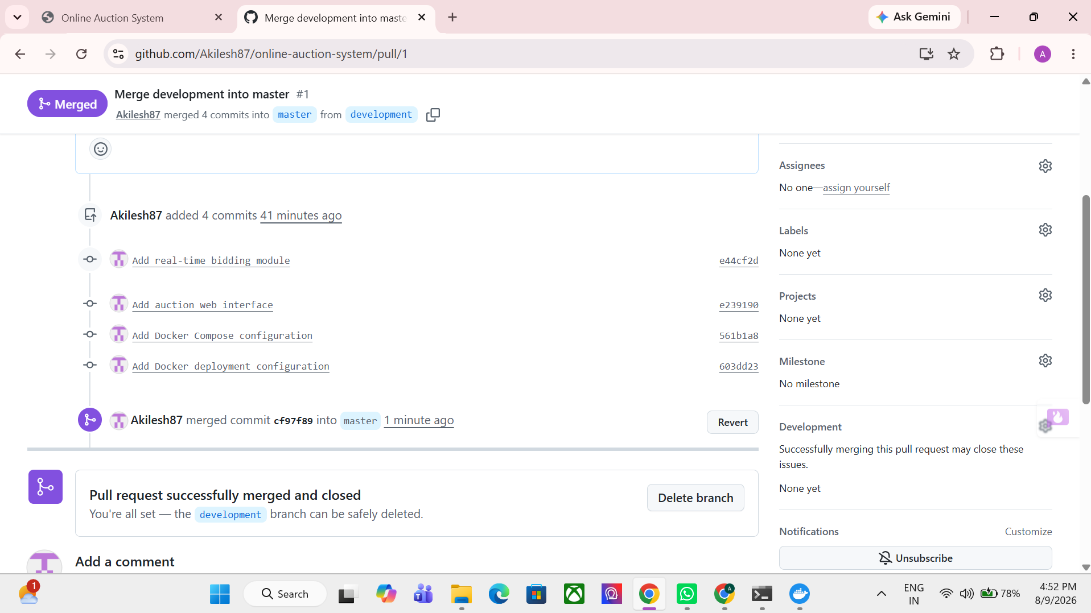

6. Commit History Analysis
Meaningful commit messages make project history easier to understand and maintain. The project history contains commits for initial setup, the bidding module, the auction web interface, Docker Compose configuration, and Docker deployment configuration.
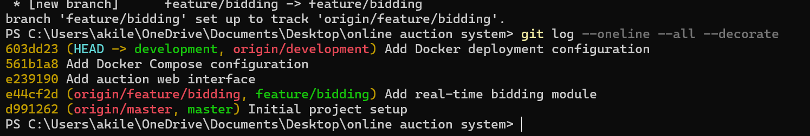

7. Docker Environment Design
Docker is suitable for this project because it packages the web application and its runtime environment into a reproducible container. This reduces differences between development and deployment environments and makes the application portable.
The main component containerized in this assignment is the web application served by Nginx.

8. Dockerfile Development
The Dockerfile uses a lightweight Nginx Alpine base image and copies the project files into the Nginx web root.
FROM nginx:alpine
COPY . /usr/share/nginx/html
EXPOSE 80
CMD ["nginx", "-g", "daemon off;"]

Dockerfile Instructions
• FROM selects the base Nginx Alpine image.
• COPY places project files in the Nginx HTML directory.
• EXPOSE documents the container's HTTP port 80.
• CMD starts Nginx in the foreground.
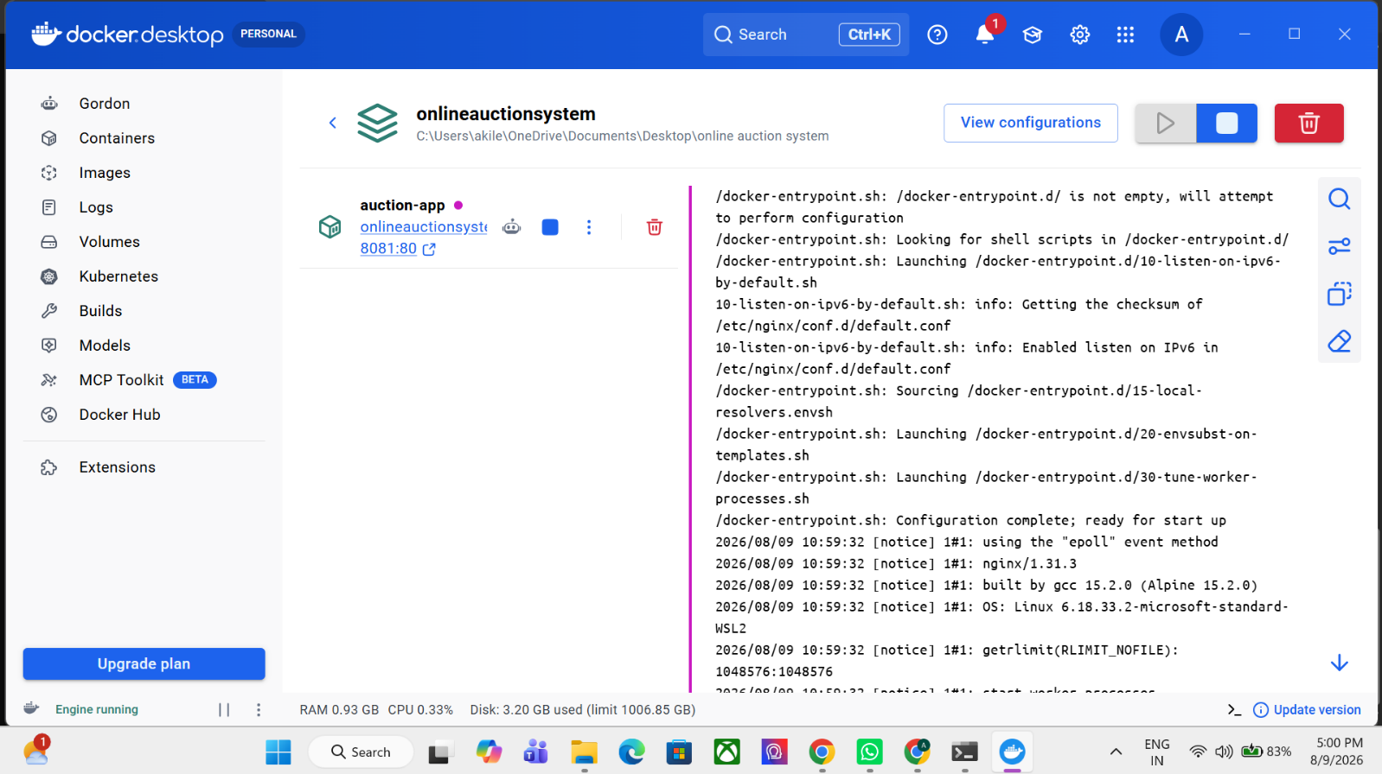

9. Docker Compose Design
Docker Compose defines the auction application as a service, builds the image from the local Dockerfile, maps host port 8081 to container port 80, and mounts the project directory into the Nginx web root.
services:
auction-app:
build: .
container_name: online-auction-app
ports:
- "8081:80"
volumes:
- .:/usr/share/nginx/html

10. Container Deployment and Testing
The application was built and started using Docker Compose. Port 8080 was already in use, so host port 8081 was selected and mapped to container port 80.
Command used:
docker compose up --build
The application was then opened in a browser using http://localhost:8081. The Online Auction System page displayed the Smartphone auction item and current bid. Selecting Place Bid displayed a successful bid message. 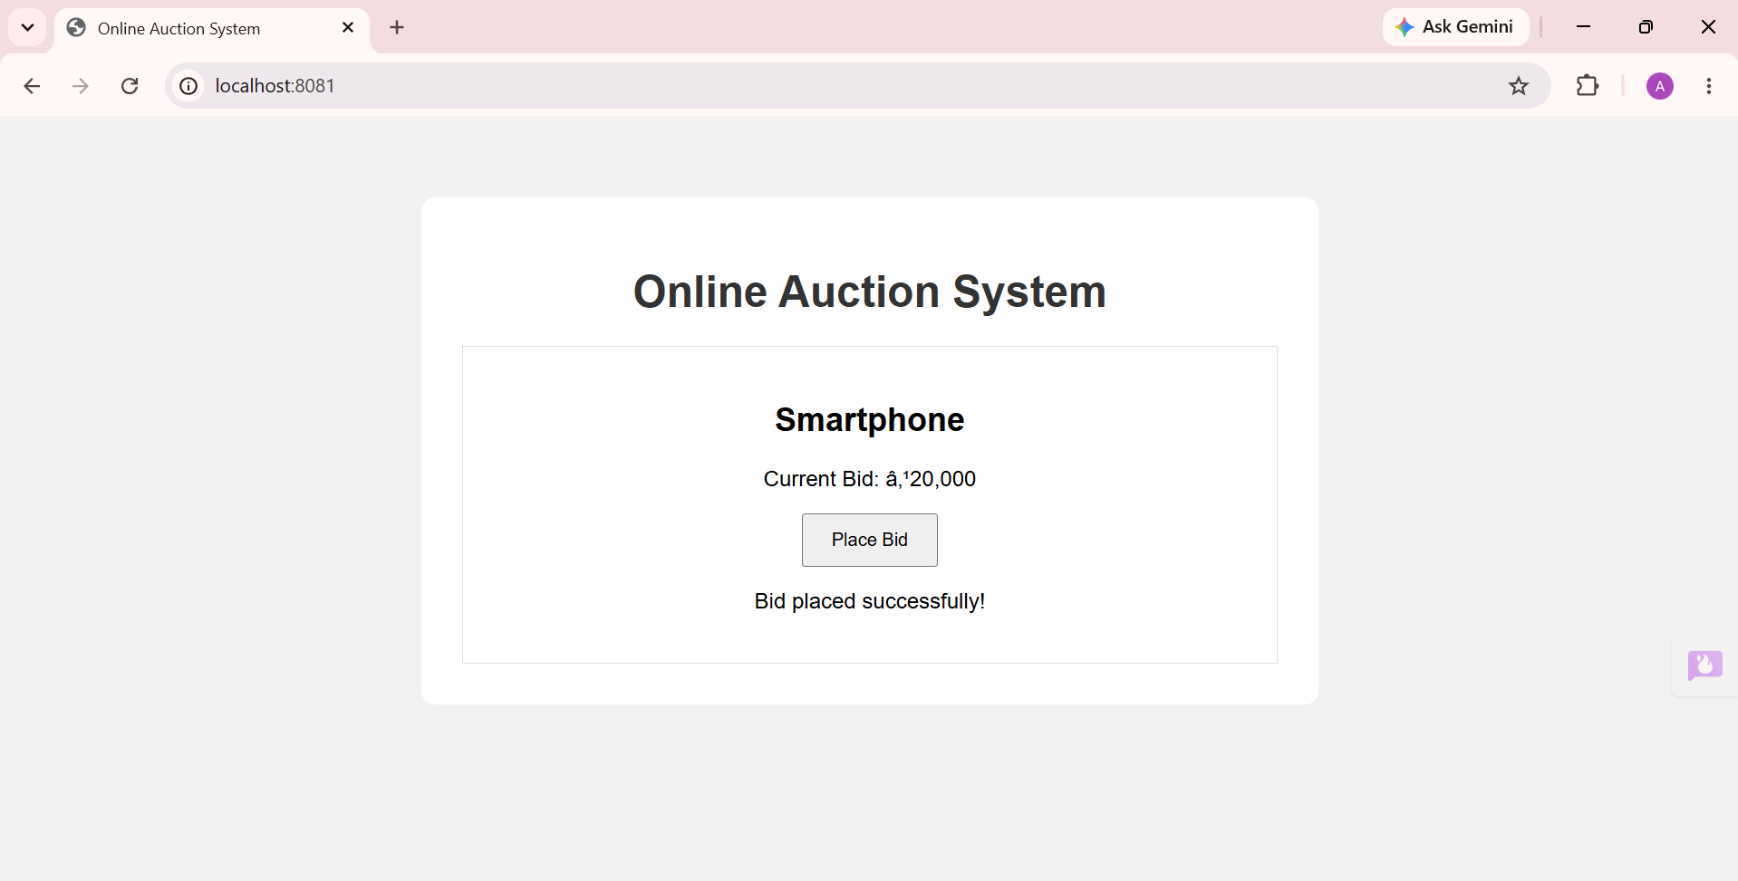

11. Benefits of Git and Docker
Benefit | Contribution
Collaboration | Git allows developers to work on branches and integrate changes through merges and pull requests.
Version Management | Commit history provides a traceable record of project changes.
Portability | Docker packages the web application in a consistent runtime environment.
Deployment | Docker Compose simplifies building and starting the application.
Maintainability | Separate branches and meaningful commits make changes easier to understand.
Scalability | Containerized services can be expanded or separated as the application grows.

GitHub Synchronization Evidence
The local repository was connected to GitHub and the master, development, and feature/bidding branches were pushed to the remote repository. A pull request was created to merge development into master.
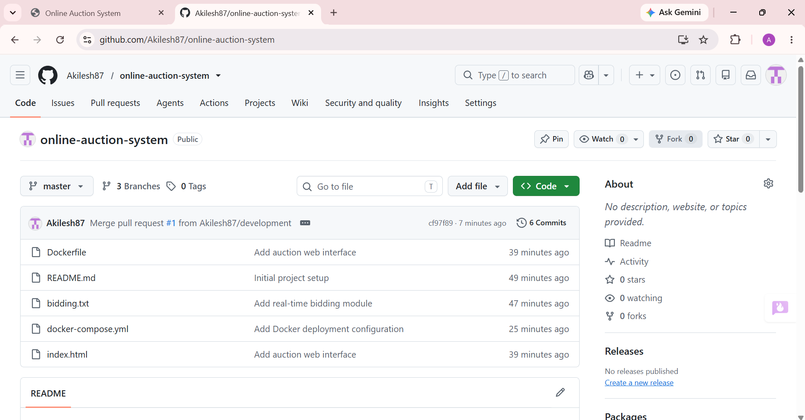

12. Challenges and Future Improvements

Challenges Encountered
• Port 8080 was already occupied by another service, so the Docker Compose host port was changed to 8081.
• The initial empty Git repository required a project file before an initial commit could be created.
• GitHub synchronization required creating a remote repository and pushing the local branches.

Future Improvements
• Add user registration and secure authentication.
• Implement persistent auction and bid data using a database.
• Support multiple simultaneous bidders and real-time bid updates.
• Add auction start/end times and automatic winner selection.
• Add backend APIs and separate frontend/backend containers.
• Add automated testing and CI/CD workflows.

Conclusion
The Online Auction System project demonstrates the use of Git for repository management, branching, commits, merging, GitHub synchronization, and history tracking. Docker and Docker Compose were used to package and deploy the web application. The application was successfully tested through a browser using localhost:8081. The workflow demonstrates how version control and containerization can improve collaboration, portability, deployment, and maintainability.

Evidence Checklist
☐ Git initialization and initial commit screenshot
☐ Branching screenshot
☐ Merge and commit-history screenshots
☐ GitHub branches and pull-request screenshot
☐ Dockerfile and Docker Compose screenshots
☐ Docker build/start screenshot
☐ Working application and Place Bid testing screenshots
☐ System architecture and Git/Docker workflow diagrams

